**Lab 5: Examining the Registry**

**Group: CyberSec_N00b**

#### Member:

#### Huỳnh Ngọc Quang (SE181838)

#### Hồ Tài Liên Vy Kha (SE181818)

#### Hoàng Kim Long (DE180860)

#### Phạm Thành Long (SE181692)

#### Nguyễn Lê Hoàng Thông (SE182533)

**Step 1.**

Unzipped the DD image

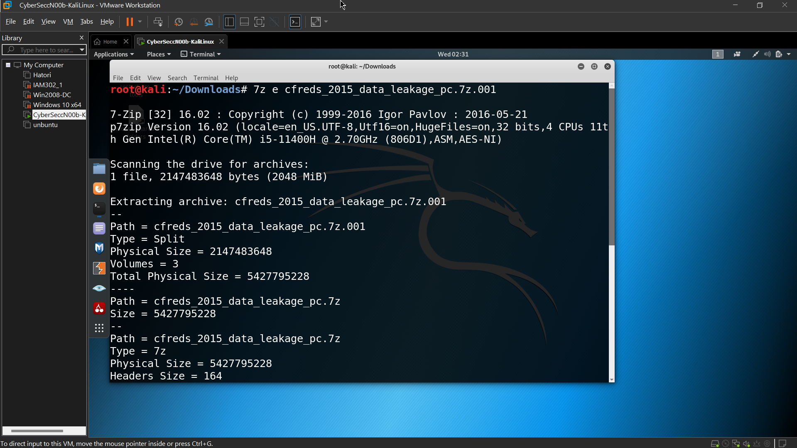 Verify the unzipped DD image

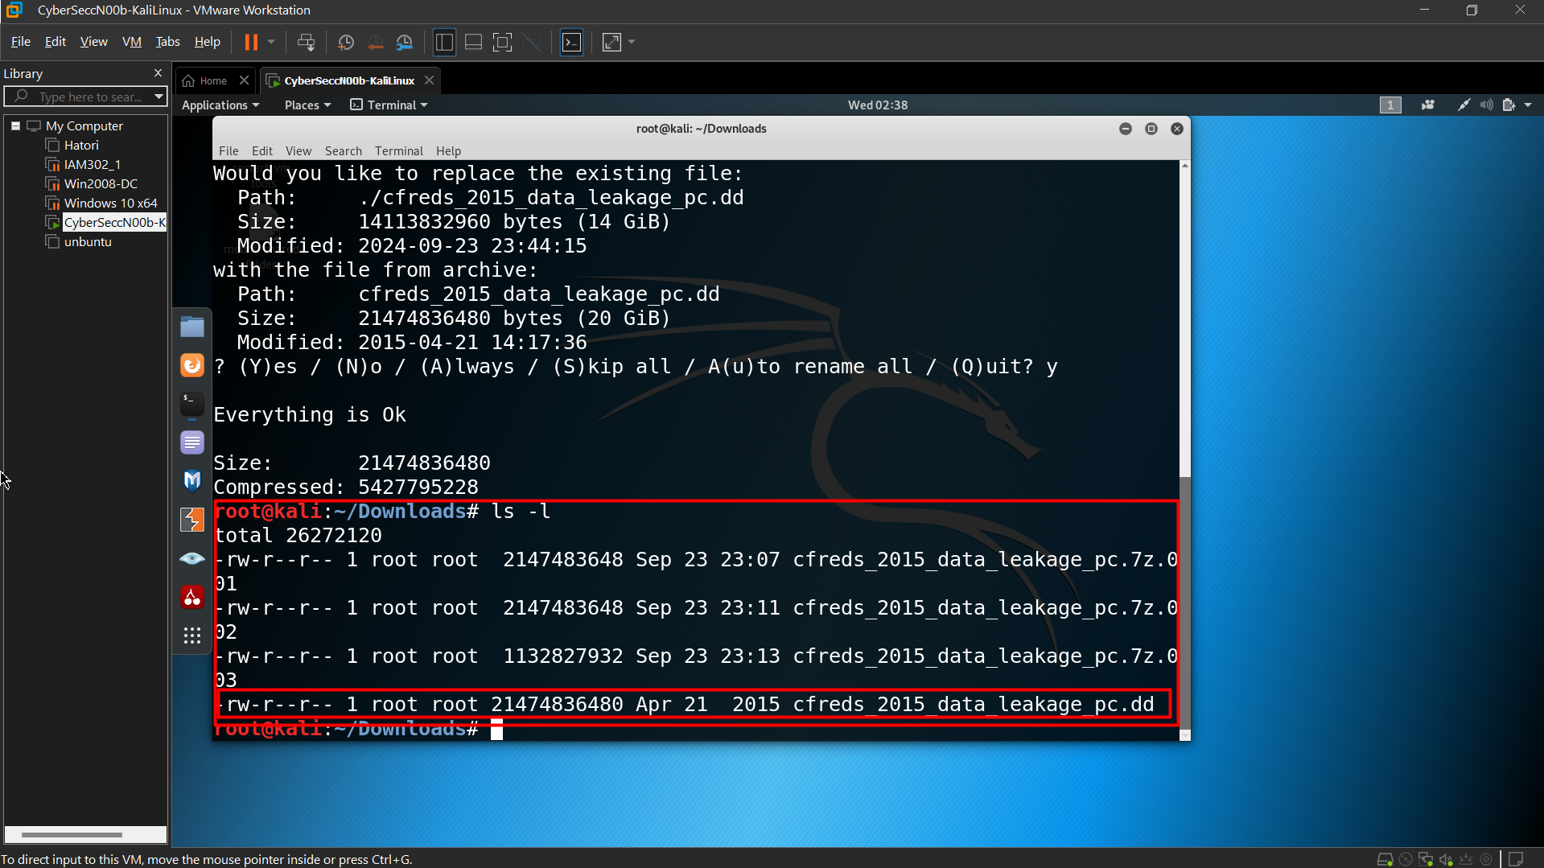 Verify the unzipped DD image with MD5

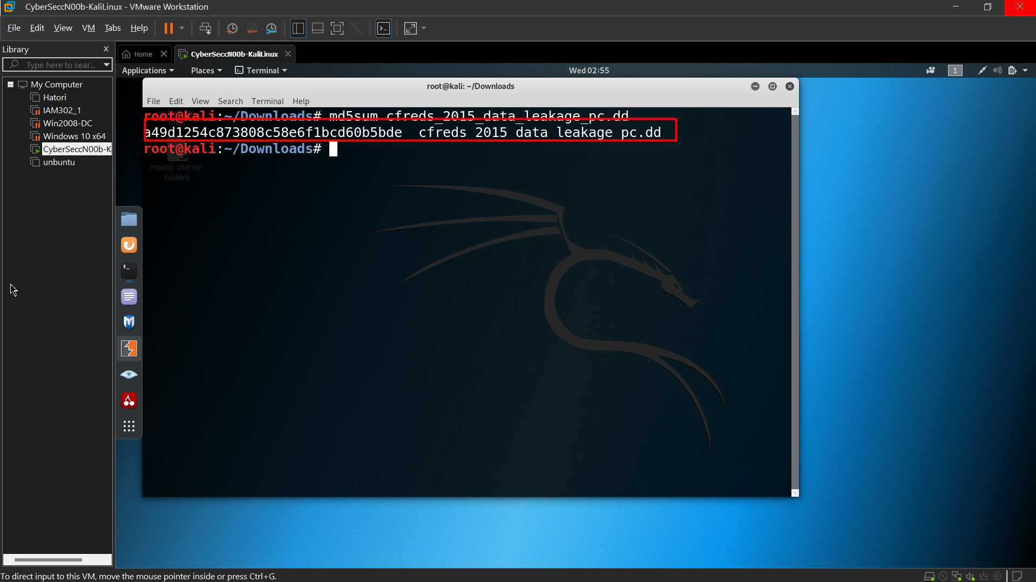 **Step 2.**

Exam partitions of the DD image using *fdisk*

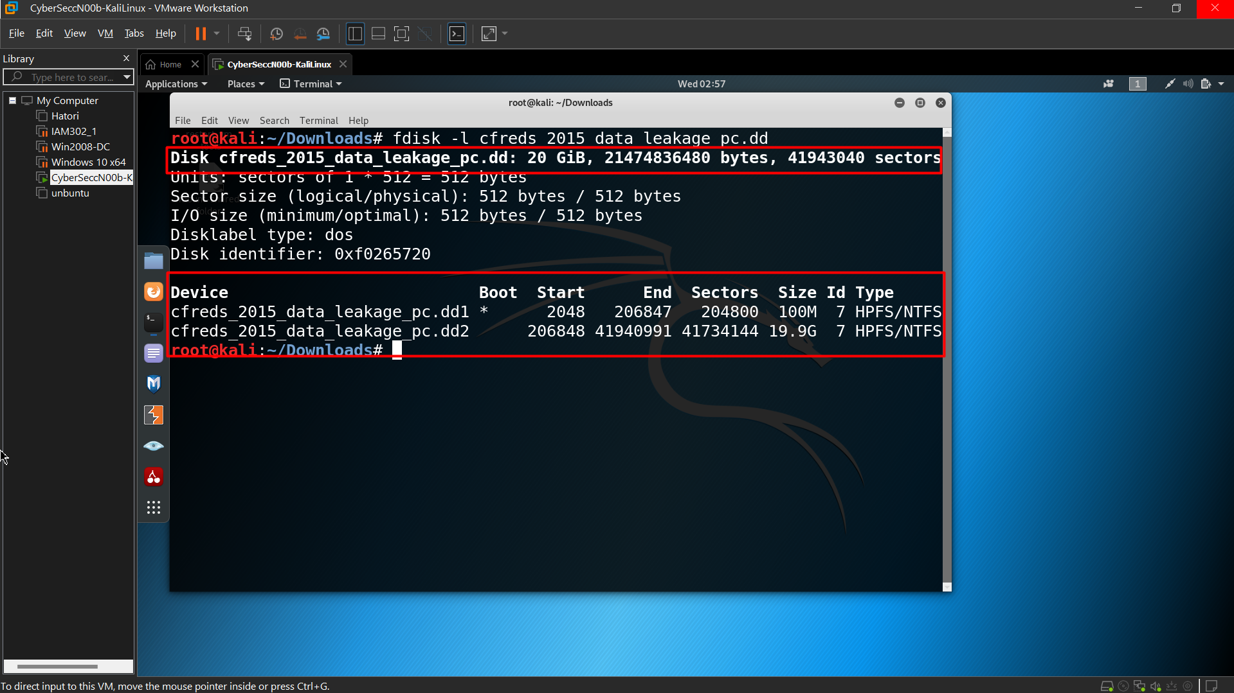 List file/directory names of the system volume

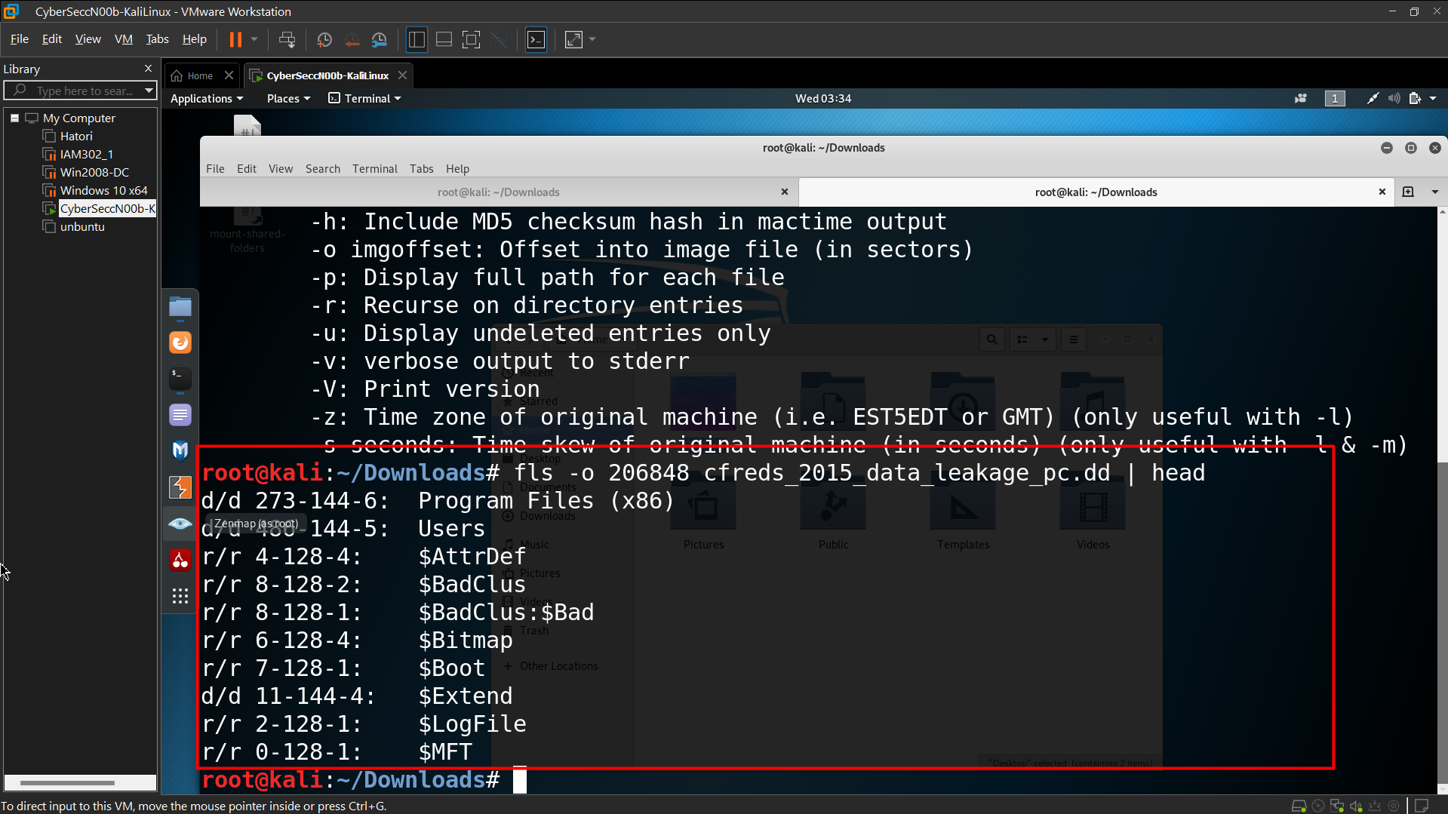

If your VM doesn’t support auto-mounting

Create a folder as the mount point

Mount partition 2 to the mounting point

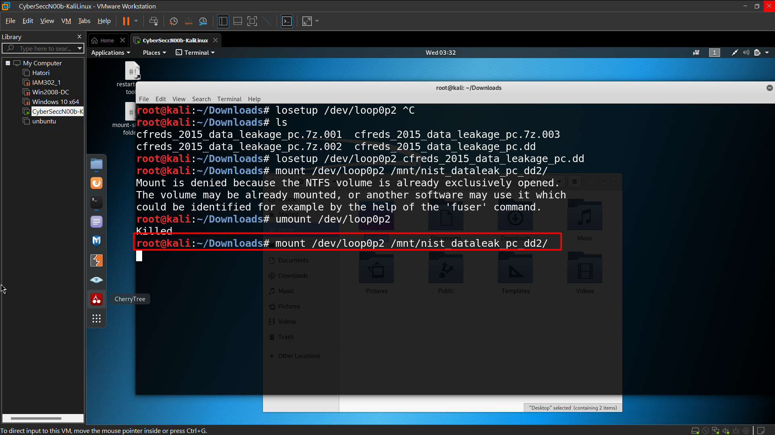

Copy HKEY_LOCAL_MACHINE (Hive) files to \lab

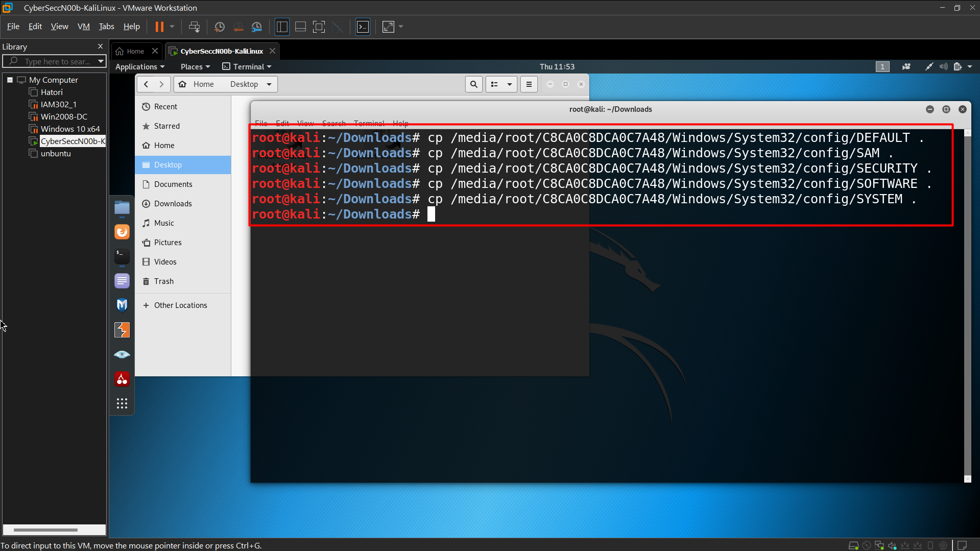

Verify five files

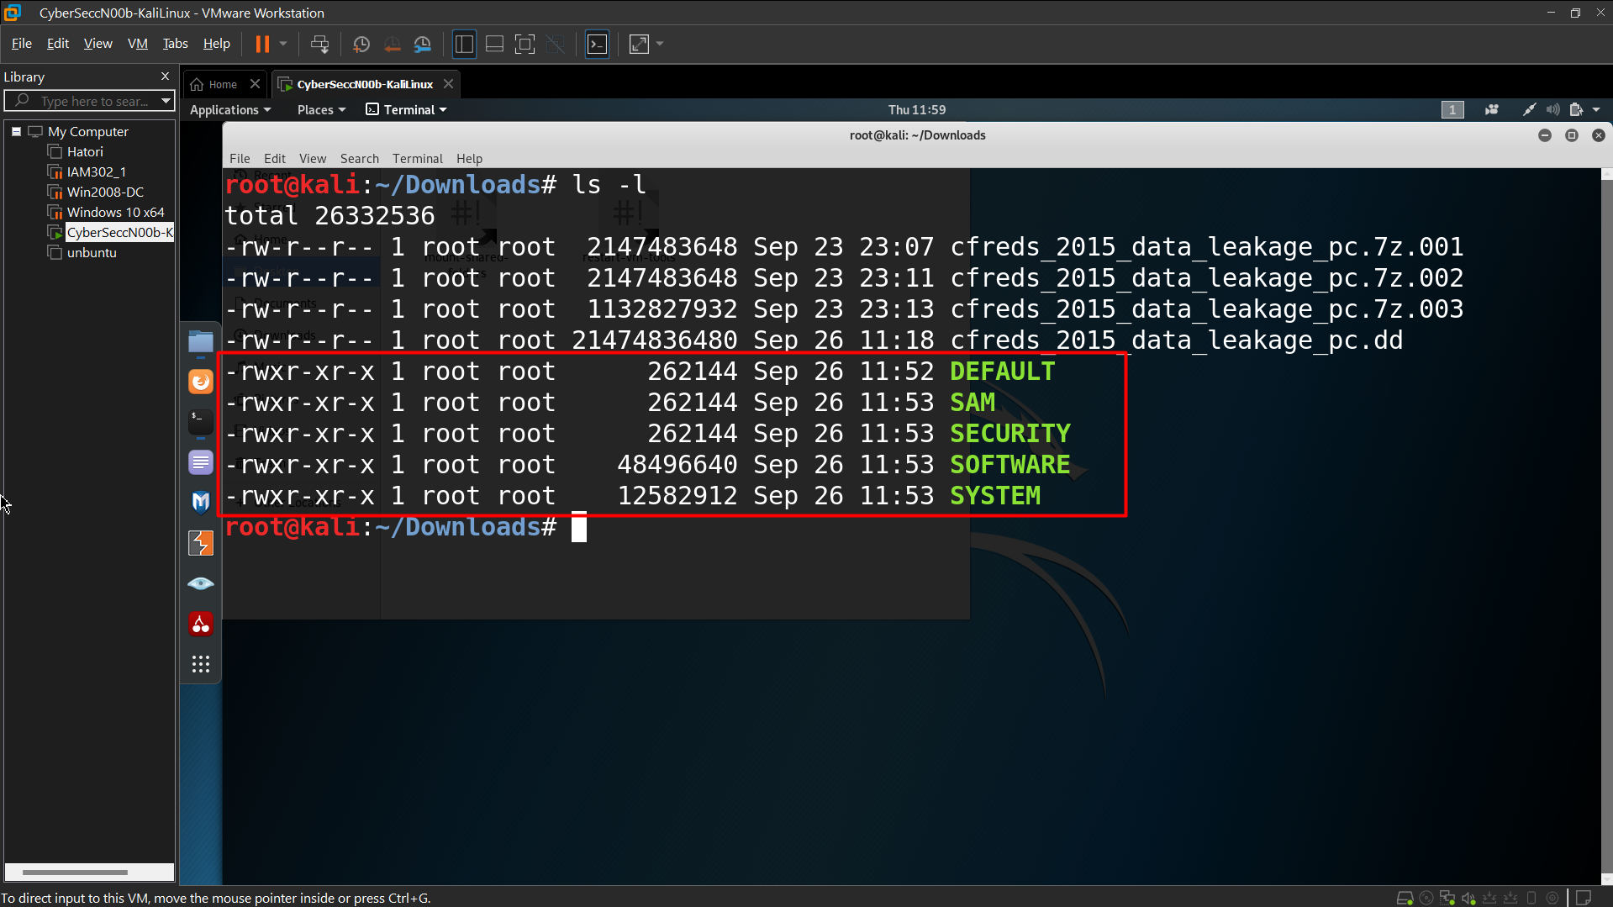

**Step 3.**

Verify you have the dd image

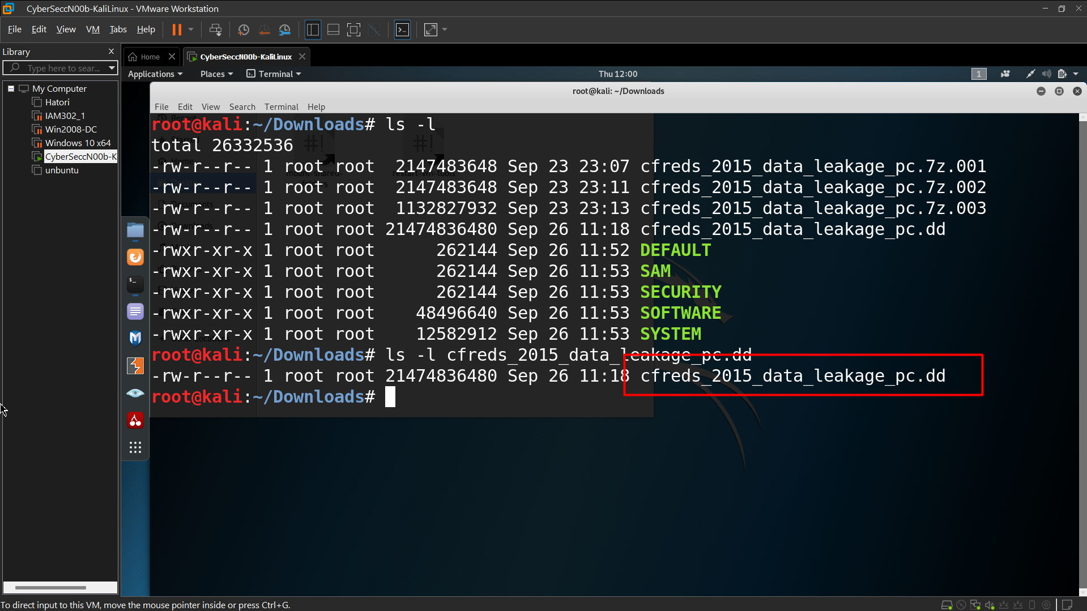 Compute MD5 and SHA1 of the DD image

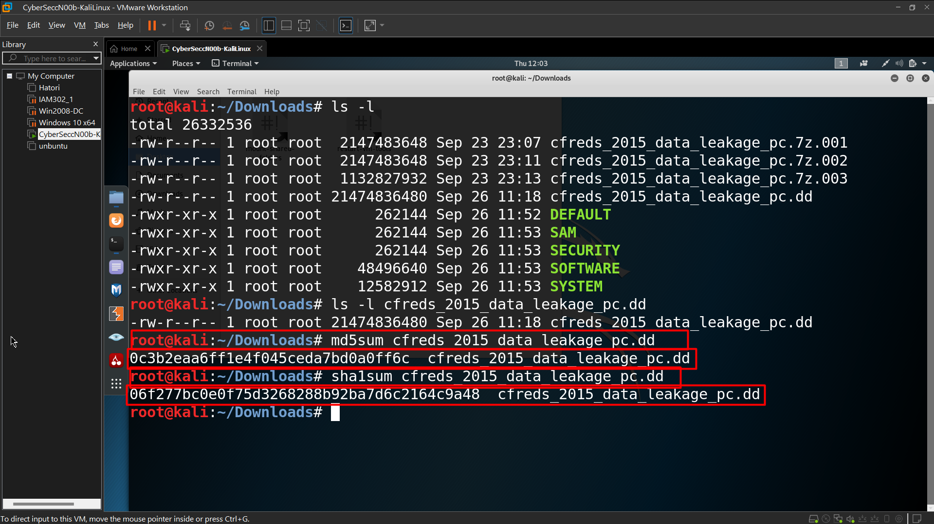 Show partitions of the image

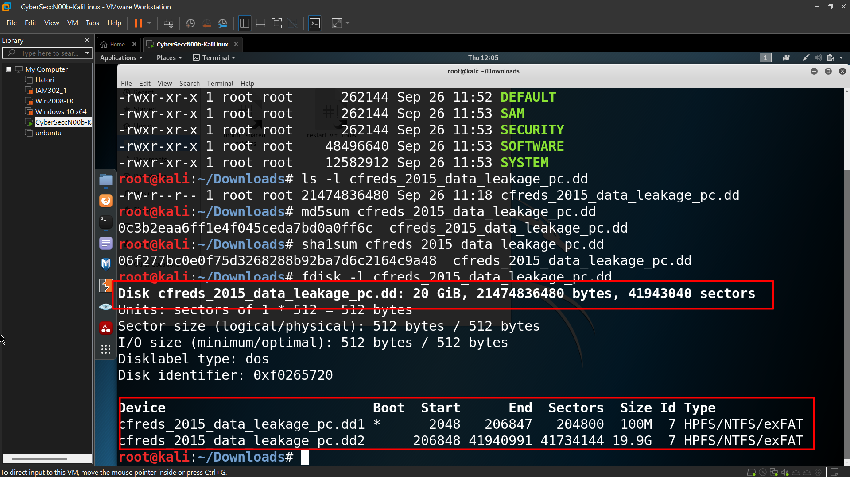 Show partitions and unallocated space using *mmls*

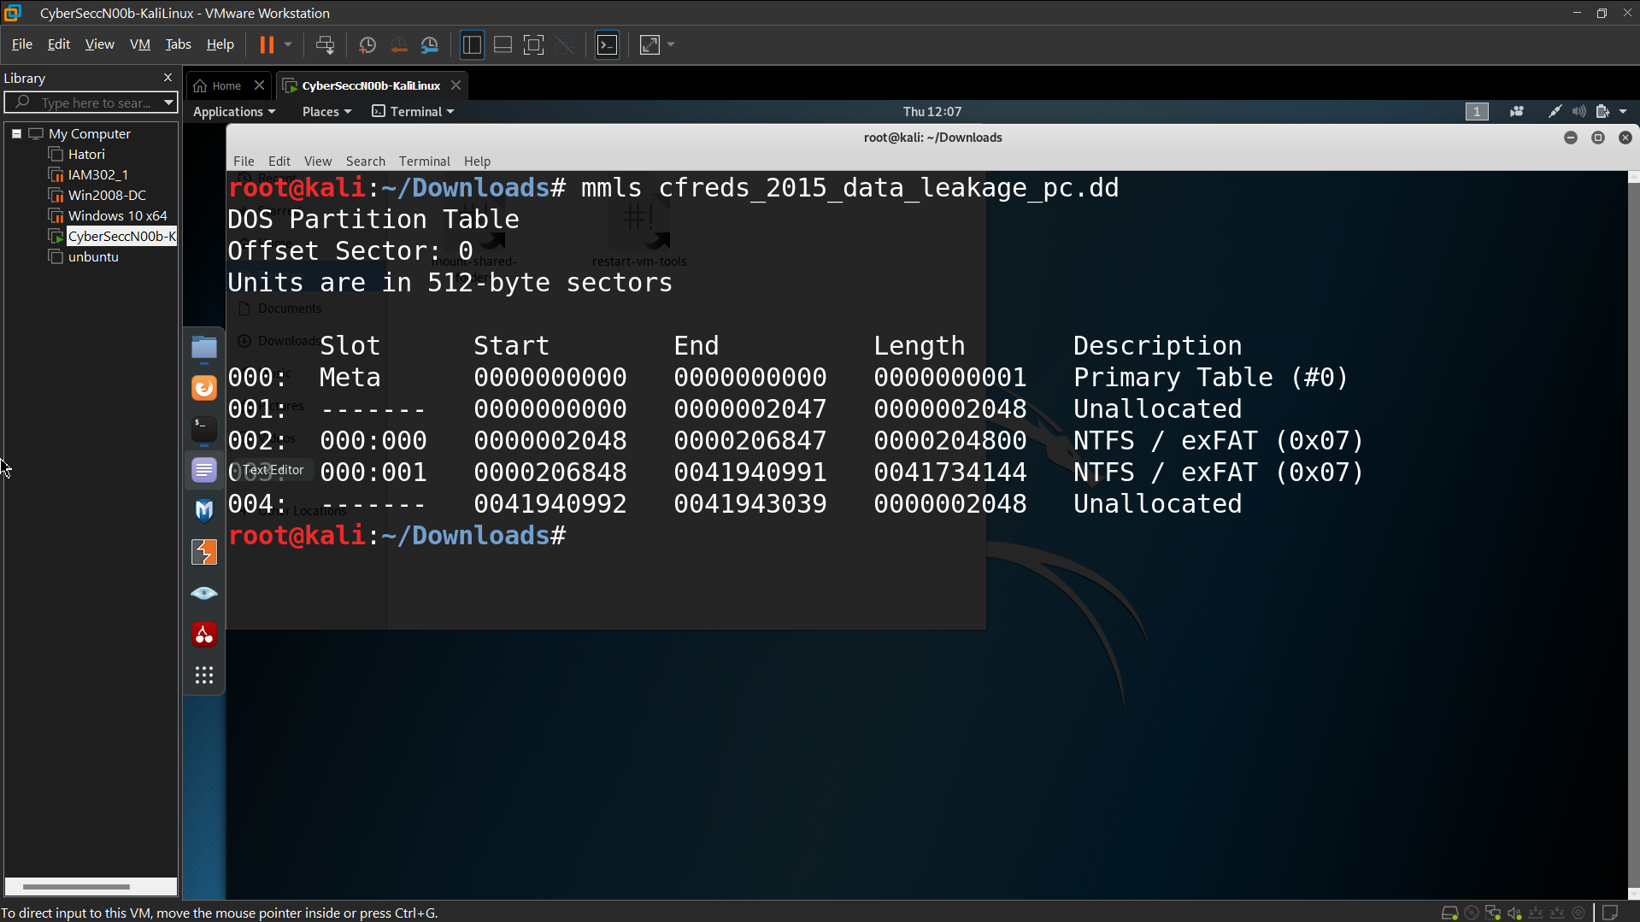 Display file system statistics and metadata information from a disk image (first partition)

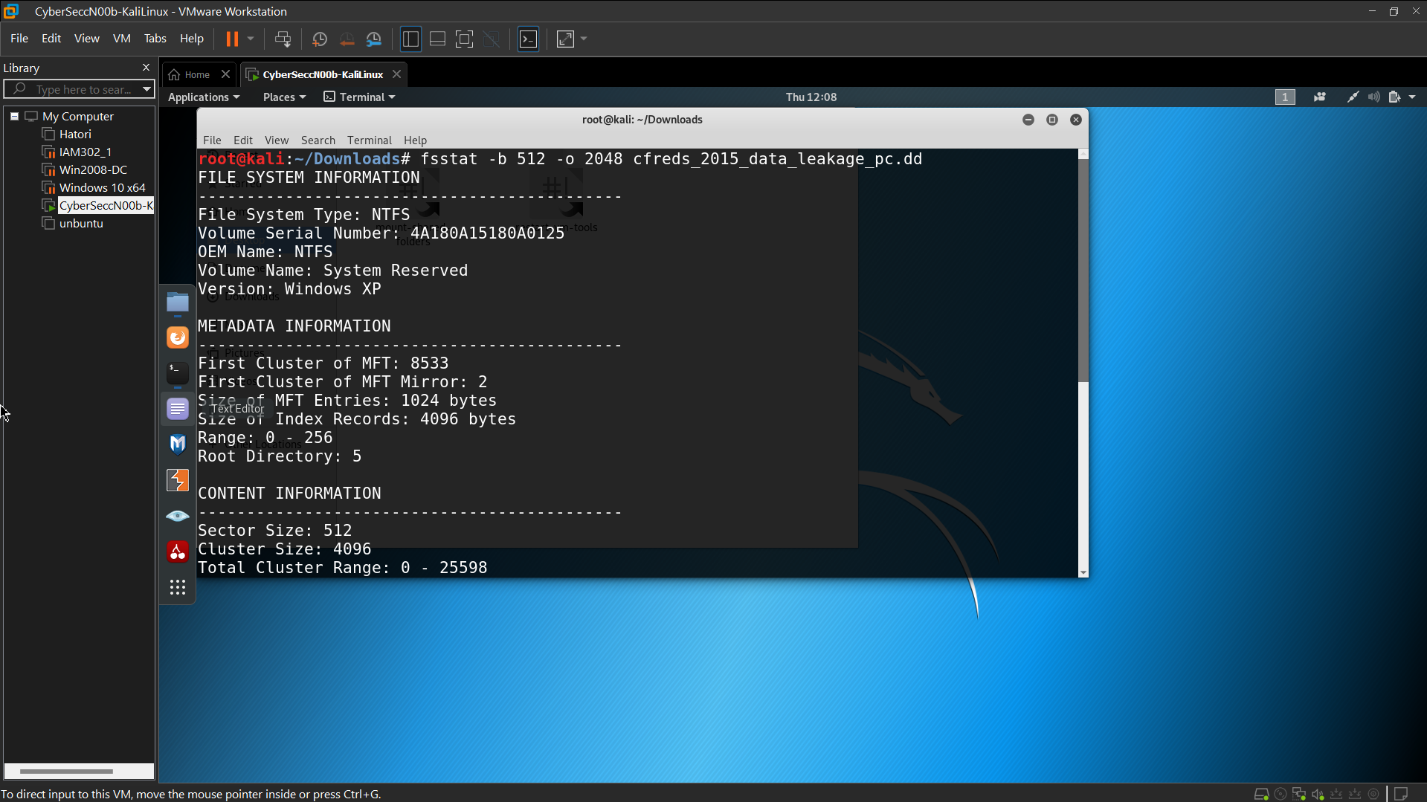 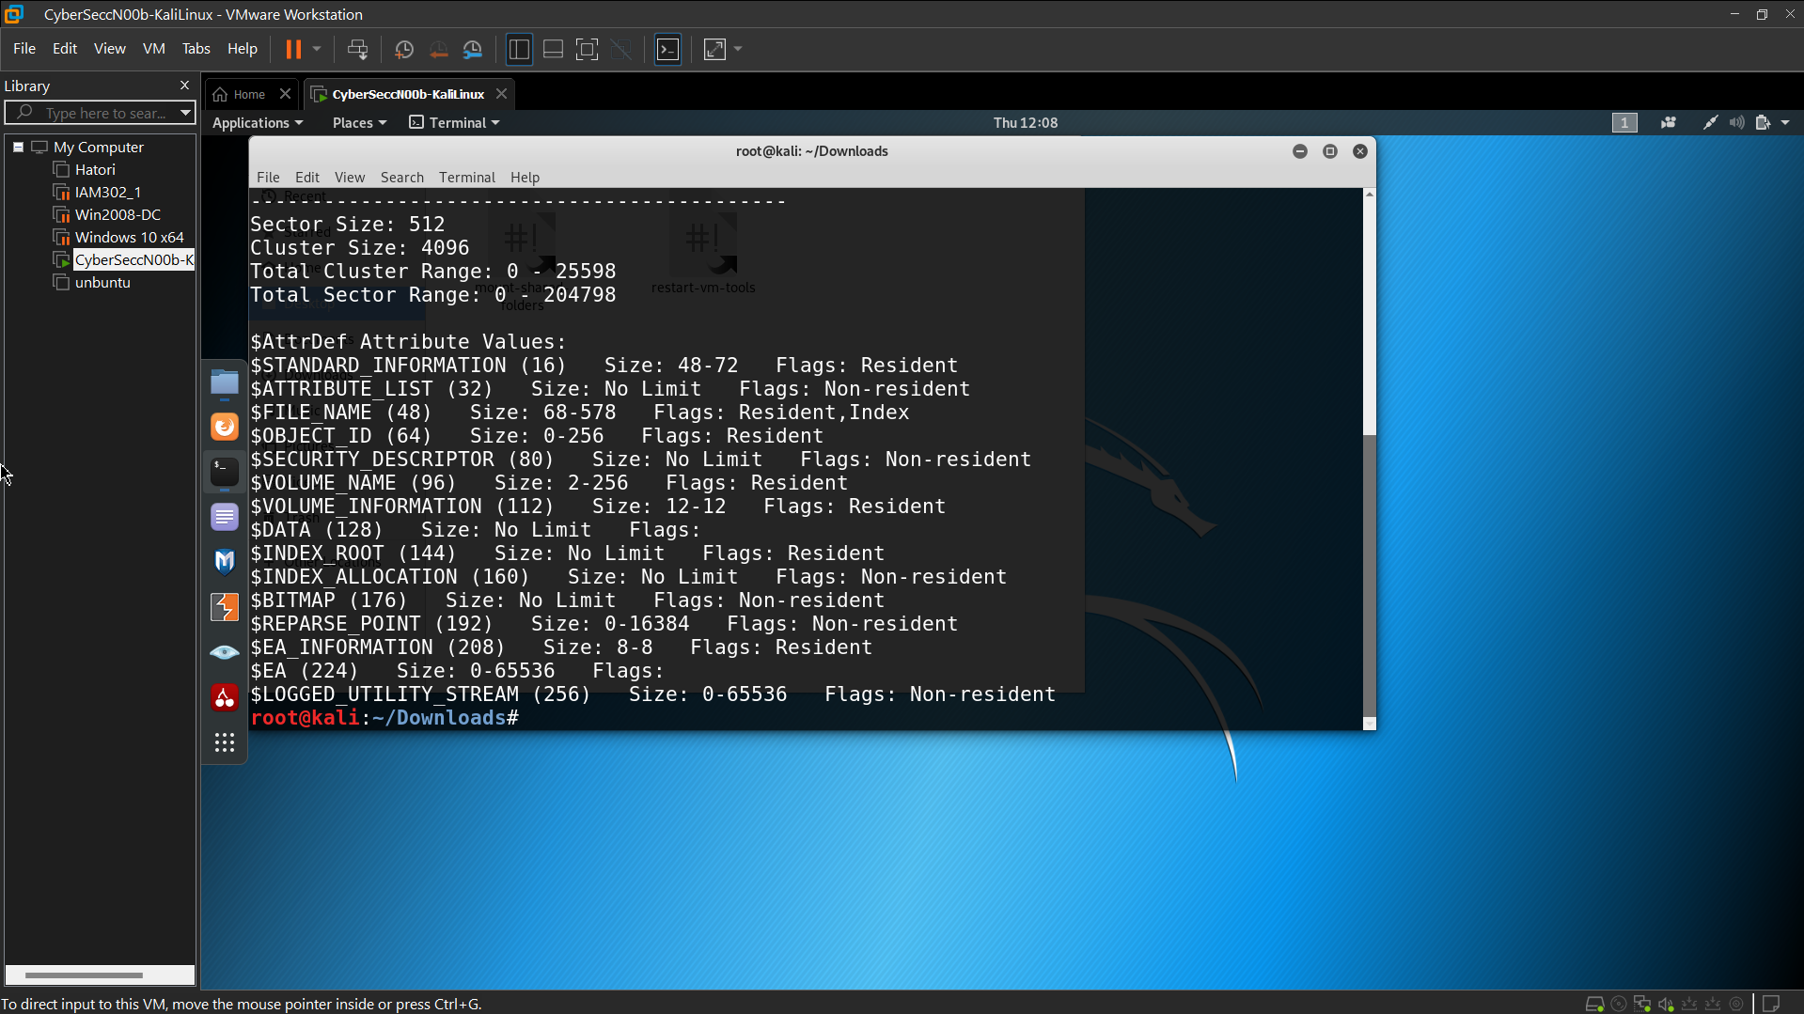 List the second partition details

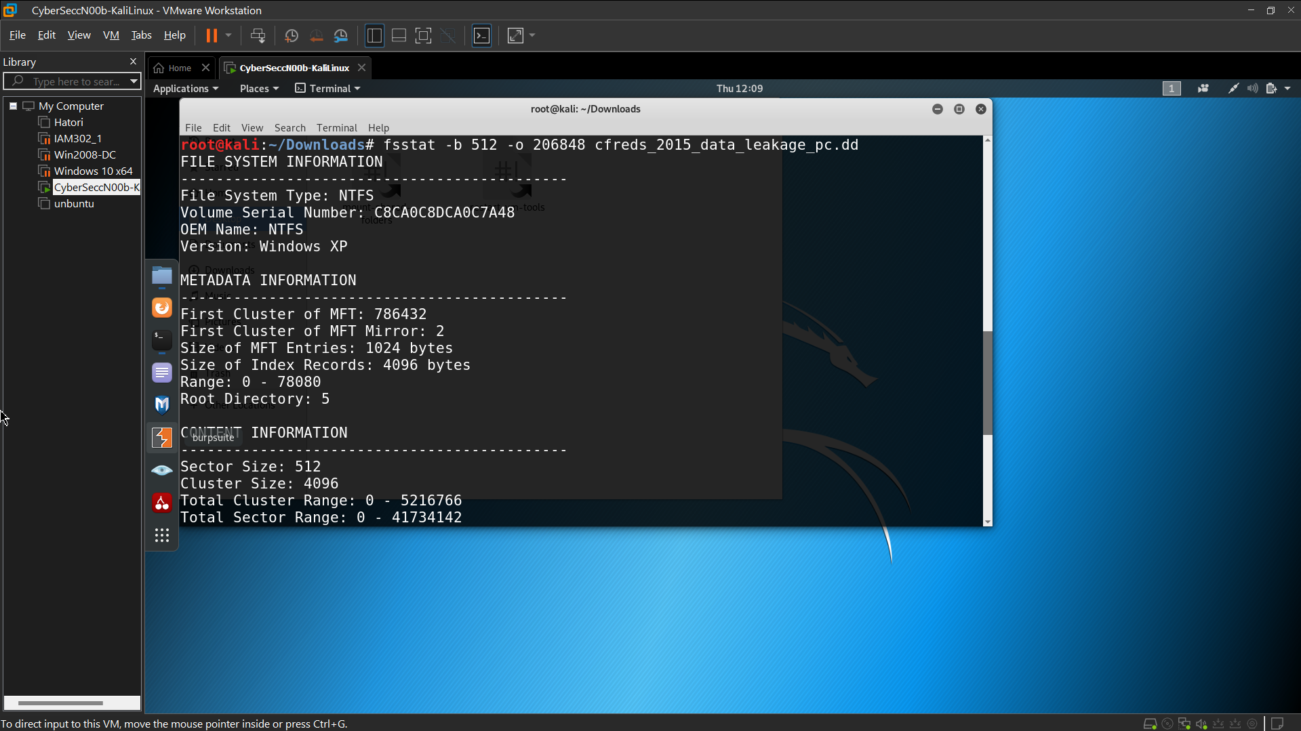 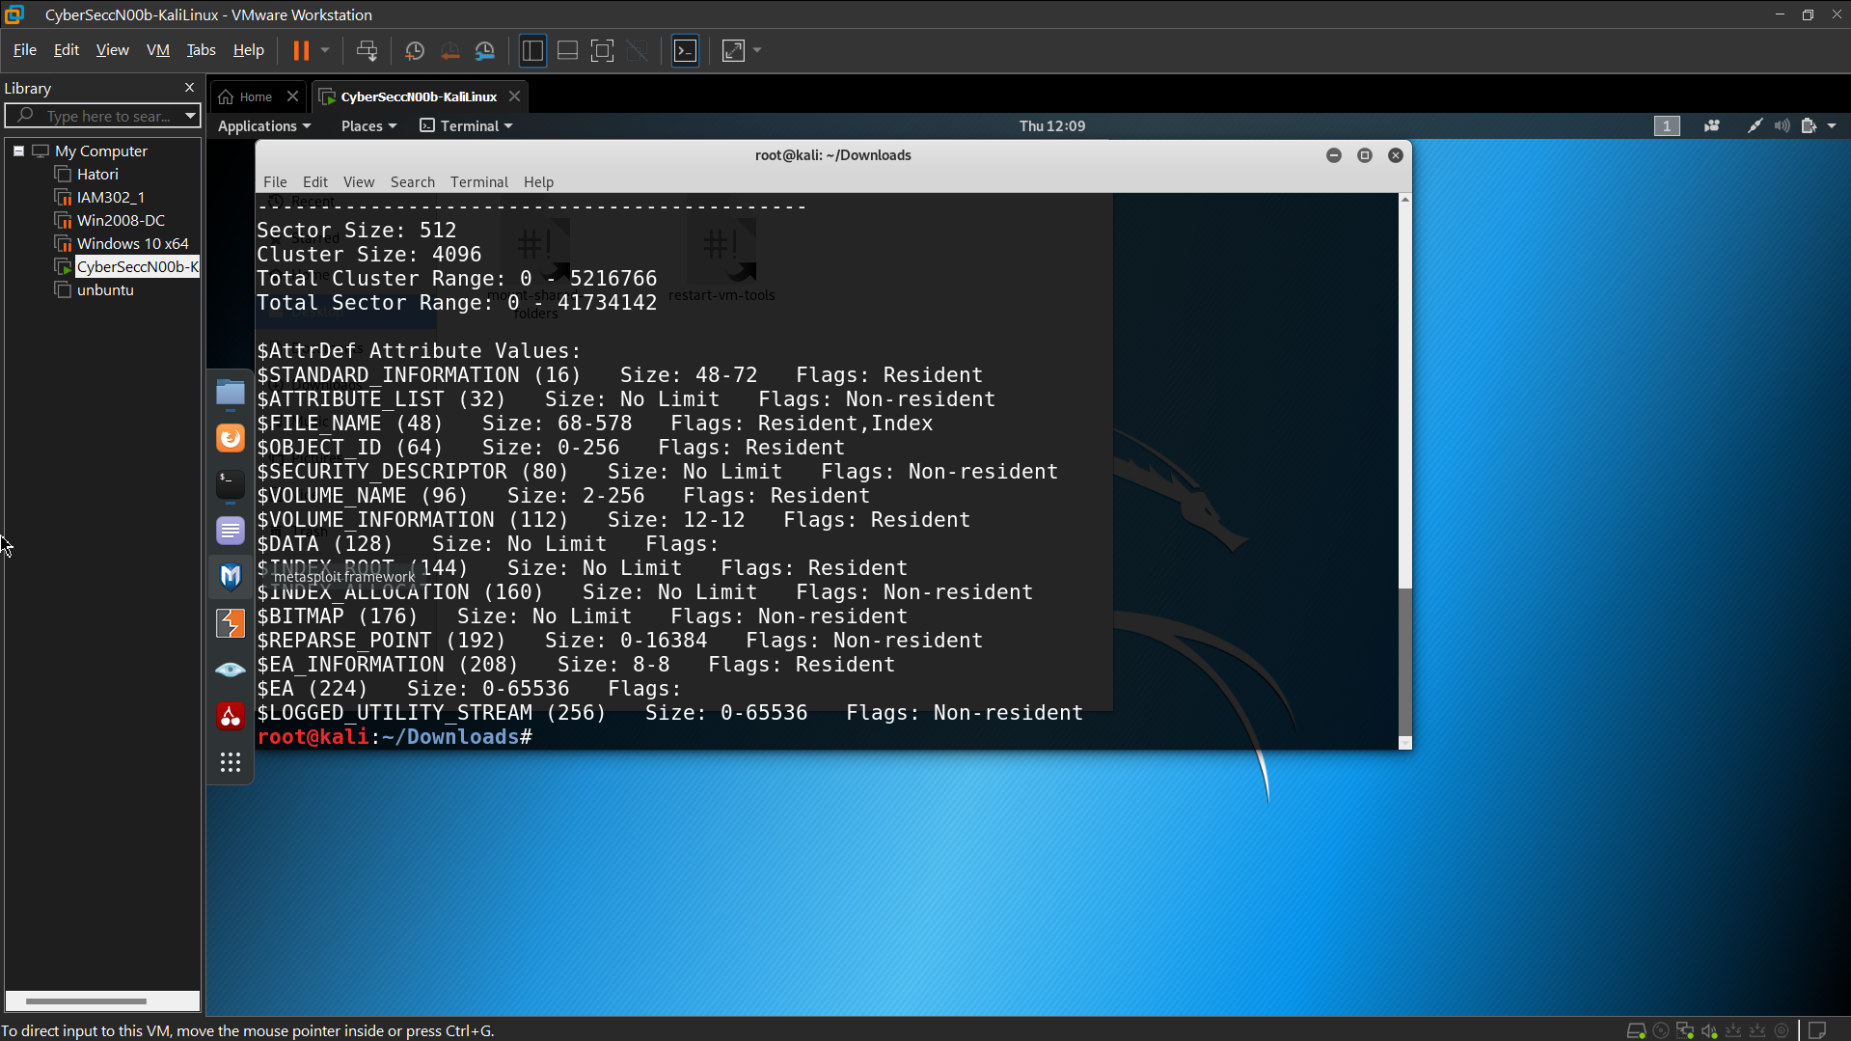 List all deleted *.docx* files in the whole partition?

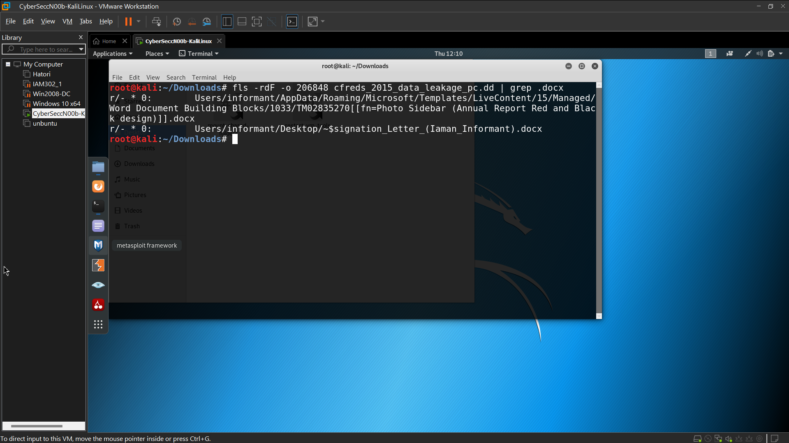 Verify Users’ information

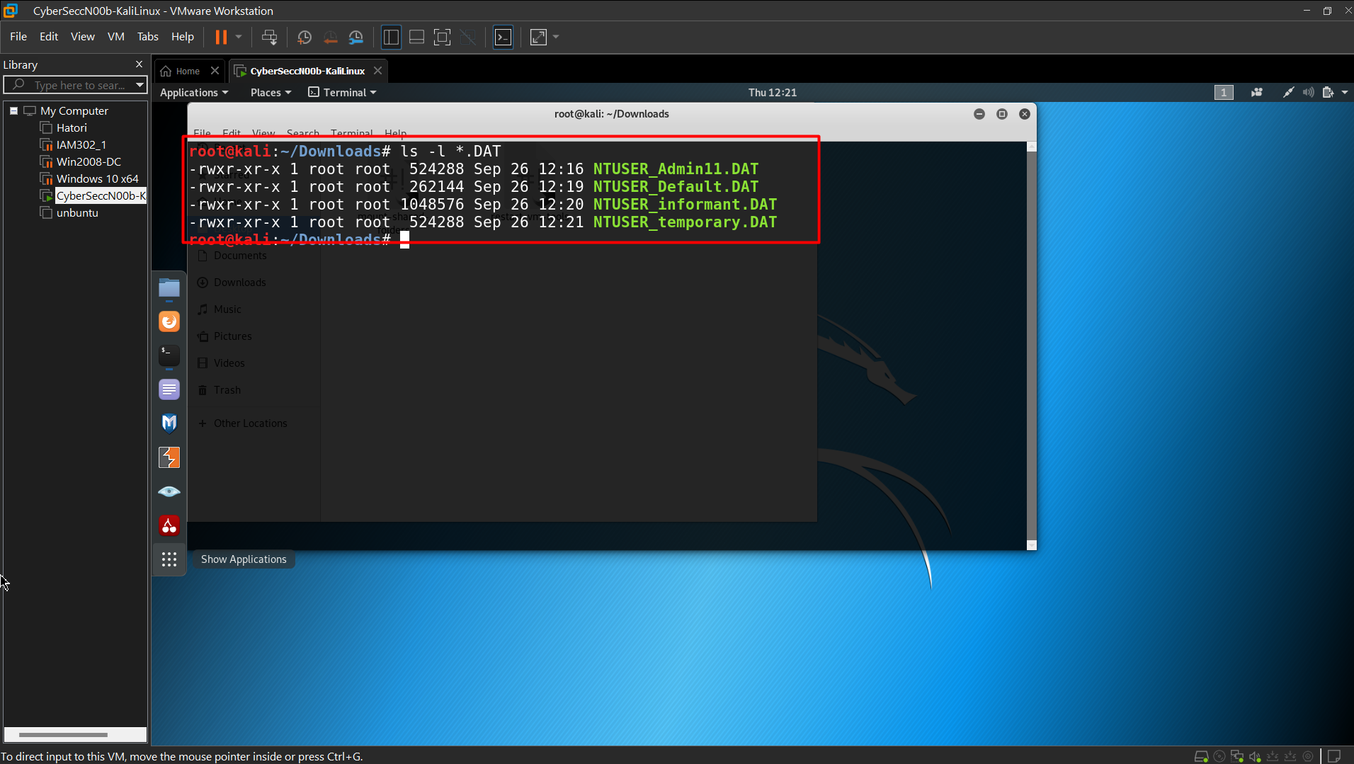 **What is the installed OS information in detail?**